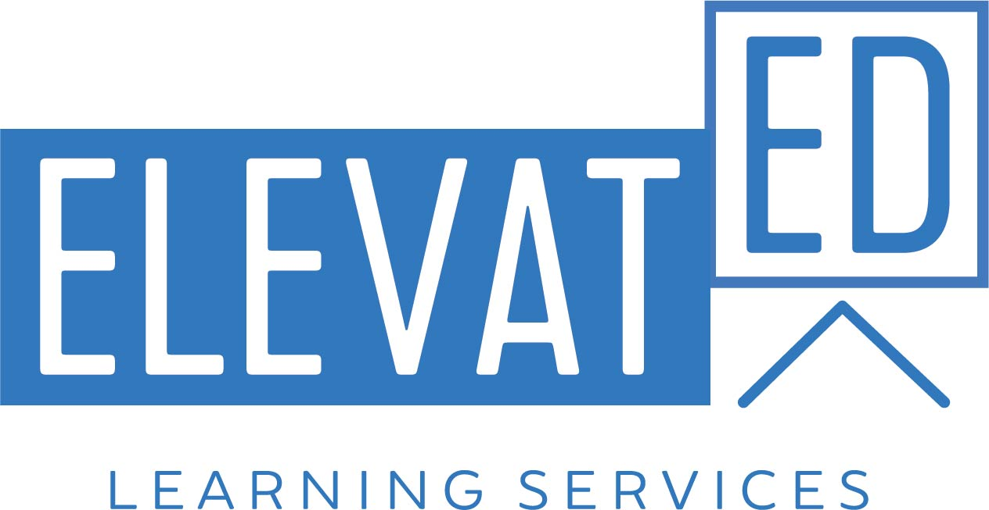

Fostering Collaborative Learning

Key Workshop Concepts:
- True collaboration is deliberately structured; it doesn’t just happen.
- Micro-structuring raises the level of student engagement.
- Identify your purpose for having students collaborate and choose a structure that supports it.
- The key to a well-structured and productive collaborative activity is the presence of all five essentials of collaboration.

AGENDA

9:00 – 9:15 Introductions and Workshop Goals
Introduction of the workshop, the workshop facilitator, the workshop driving question, the day’s objectives, and a summary of research findings on the importance and value of collaboration in the classroom.

9:15 – 9:30 Group Work v. Collaborative Work: Card Sorting Activity
The facilitator explains the difference between “group work” and truly collaborative activities. Participants demonstrate understanding by sorting a set of cards – each with a sample activity written on it – between those that contain “group work” and those that contain activities that foster true collaboration. During a whole group debrief, all participants come to consensus on the card placement.

9:30 – 9:50 The Challenges in Developing a Collaborative Classroom
Participants engage in a structure called Pairs Compare in order to generate a list of the greatest challenges in implementing student collaboration in the classroom. After being asked to prioritize the top three challenges, groups share out their ideas. Facilitator conducts a short debrief in order to discuss their experience with the Pairs Compare structure, an example of micro-structuring. Participants are told that the “challenges” list just generated will be revisited later.

9:50 – 10:00 What the Research Says about Collaboration
The facilitator shares a summary of research findings on the importance and value of collaboration in the classroom, for all students as well as specifically for ELs.

10:00 – 10:15 Micro-structuring
Participants analyze a series of sample collaborative activities in order to determine how they have been micro-structured, or structured in such a way as to ensure student collaboration.

10:15 – 10:35 Making Activities Collaborative
The facilitator assigns each group one (or more) of the “group work” cards from the card sort at the beginning of the day and asks them to micro-structure the activity on the card so as to ensure student collaboration. Groups share out their adaptations.

10:35 - 10:45 BREAK

10:45 – 11:30 Purposeful Collaboration
When planning a collaborative activity, the first step is determining the purpose for having students collaborate: What is the goal? What are they trying to achieve/produce? Once a teacher has answered this question, then it becomes easier to select a possible collaborative structure to use. The facilitator walks through the Purposeful Collaboration chart and explains the different columns, each containing a distinct purpose for collaboration. Each group is assigned one sample task that aligns with one of the purposes on the chart. They must review a set of possible collaborative activity structures in order to find the best one geared towards their group’s purpose. They subsequently present their sample task, purpose and structure out to the whole workshop group.

11:30 – 11:50 Individual Application: Making Activities Collaborative
Participants consider an actual classroom activity they are interested in transforming into one that is more collaborative; they determine the purpose for collaboration, and then select an appropriate structure that fits that purpose.

11:50 – 12:15 Essentials of Collaboration Stations Activity
Participants engage in a stations activity where each station highlights a different essential element of collaboration (structured independence from the teacher, applying interpersonal skills, deliberate grouping, interdependence, and group and individual accountability). After having explored and shared the materials at each station, participants are asked to apply what they have learned by determining how they will implement that essential in the planning of the discipline-specific culminating task idea. Participants will have 15 minutes per station to explore materials and answer the application question(s) on their stations activity guide.
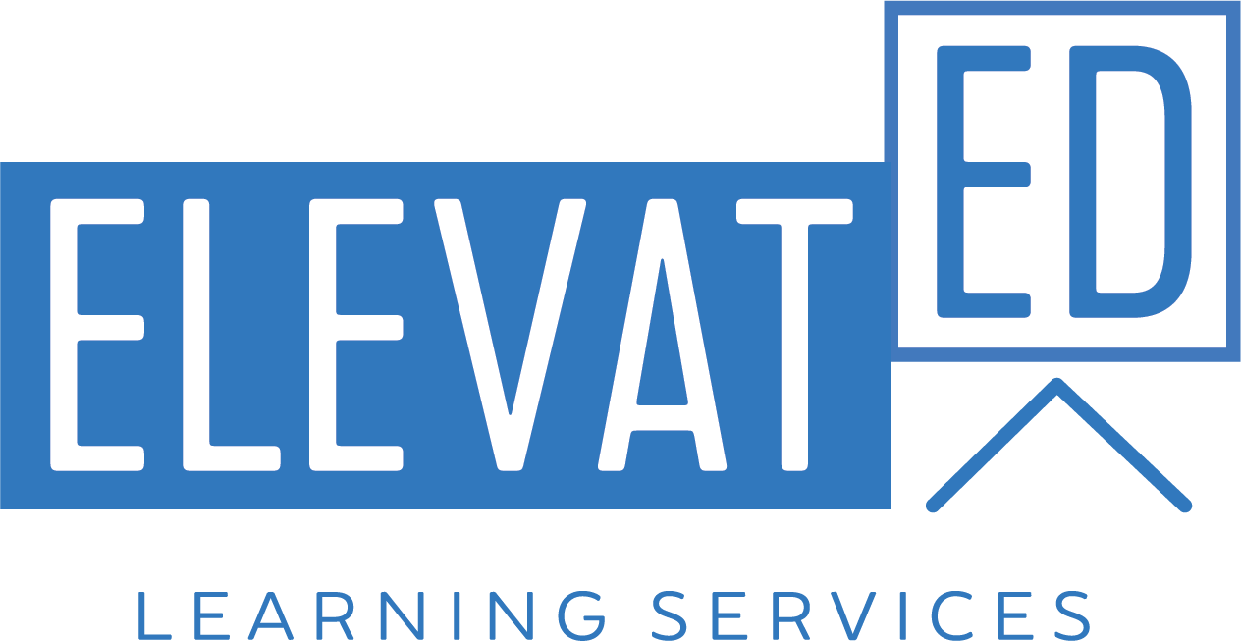
12:15 – 1:00 LUNCH

1:00 – 2:05 Essentials of Collaboration Stations Activity (continued)

2:05 – 2:20 Essentials of Collaboration Stations Activity Debrief
The facilitator leads a debrief session of the stations activity, in which participants have the chance to ask questions, react to the materials, and share new understandings. Participants also discuss how this stations activity itself adheres to the elements of collaboration.

2:20 – 2:50 Individual Application: Incorporating Essentials of Collaboration
Participants have the opportunity to apply their learning of the essentials of collaboration by designing a more substantial collaborative activity for their own classroom and specifying how that activity incorporates each one of the essentials of collaboration.

2:50 – 3:10 Q & A on Collaboration
Participants have the opportunity to ask any lingering questions they still have about designing and implementing collaborative activities in the classroom.

3:10 – 3:30 Reflection on Key Workshop Concepts and Evaluations
The facilitator draws participants’ attention to the “challenges” chart developed and posted earlier in the day and asks each participant to reflect on one of the challenges that they now feel better equipped to meet head-on and why they feel that way. Each participant shares orally with the entire workshop group. The facilitator reviews the key workshop takeaway concepts before distributing the evaluation forms.

